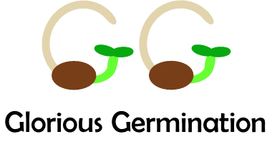
Game Description and Instructions

GLORIOUS GERMINATION – Do Microbes Help or Hinder Germination?
Game created by Dylan Eisenbrandt and Julie Beckstead.
Thanks to Alexandrite Greenhouse, Erik Hallstrand, Mackenzie Rowley, Margarita Washington, and Abbey Shuster for help testing and refining the game. Thanks to Sheila Schulz for making cards.
Biology Department, Gonzaga University, Spokane, WA

DESCRIPTION:

Today, we will explore how microbes that live within seeds may help seeds to germinate. This is important because plants today are facing many challenges both in agriculture and in our natural habitats. Disease and environmental stressors (such as drought, heat, abrupt freezes, and high salt content in the soil) reduce seed germination and seedling growth. Climate change is only going to make these stressors more of a challenge. The beneficial aspects of microbes have largely been unexplored, and they are an untapped resource that has the potential to solve important problems in our world.

GAME GOAL:

The goal of the game is to germinate before the other team players. Endophytes reduce the number of days needed to germinate and benefit the seed. Pathogens interfere with germination progress. Additionally, endophytes and pathogens interact with each other sometimes helping the seed and sometimes hurting the seed.

OBJECTIVES:

At the completion of this game, you should be able to

- Identify traits used to distinguish one microbe from another.
- Describe what an endophyte is.
- Identify important plant pathogens.
- List the major types of plants.
- Outline different types of species interactions.
- Explain how germination varies by species and how microbes can impact the timing of germination.
- Explain how climate change can alter the interactions of the endophytes with the plants for different habitats.
- Collect game data and apply these data to real world scenarios involving seeds and microbes.

Part I: Description and How This Game Came to Be

This card game is created from scientific research that is being conducted at Gonzaga University as part of a USDA funded program called Seeds For The Future (thereafter “Seeds”). The primary focus of the program is to investigate seeds, their microbes, and potential applications.

Students in the Seeds Program set out to isolate microbes from seeds and determine whether the microbes were beneficial, neutral, or harmful. Microbes were isolated from within the seeds and not on the seed surface. Microbes, such as bacteria and fungi, that live within healthy plant tissues, including seeds, are called Endophytes. Frequently, endophytes have been associated with promoting plant growth but often their roles are unknown. Students in the Seeds Program grew several endophytes from multiple seed species. The students identified the endophytes’ growth form, recorded their morphological (such as shape, form, and color), and how they interacted with other microbes. For example, a bacterium and a fungal species were placed in a growth environment together to determine whether the bacterium would inhibit fungal growth or whether the two microbes would coexist. Additionally, samples were prepared for genetic testing to identify the endophytes to the species level.

If these endophytes limit growth of harmful bacteria and fungi, then they could be used to control plant diseases. Additionally, the endophytes could be beneficial to plants by promoting faster seed germination and seedling growth under stressful conditions, like drought or high heat. In the real world, these endophytes when applied to seeds could result in better yields in agricultural or help plants to establish on restoration lands following wildfires. Understanding what is living in seeds could provide benefits to humans and natural ecosystems.

Link to Seed For The Future REEU Program:
www.gonzaga.edu/SeedsForTheFuture

Part II: Game Terminology

Plant and Ecology Terms:
Antagonist: organism that opposes or negatively impacts another organism (enemies).
Bacterium (pl. Bacteria): one celled organism that lacks organelles (little organ-like structures inside cells).
Commensalism: an interaction between two organisms in which one benefits and the other neither benefits nor harms.
Colony: In microbiology, a colony is a group of bacteria, fungi, and other microorganisms grown from the same mother cell in the lab.
Endophyte: bacteria and fungi living within healthy plant tissues and seeds. The name translates to “inside plant”.
Evergreen trees: softwood trees with needles for leaves and seeds found within a cone.
Forb: a small flowering herbaceous plant with a non-woody stem that is not a grass.
Fungus (pl. Fungi): an organism that reproduces using spores and feeds on other organisms.
Germination: a plant beginning to grow from a seed.
Grass: an herbaceous, non-woody plant with narrow leaves and wind-pollinated flowers.
Hardwood trees: trees with typically broad leaves and true flowers.
Habitat: the natural home or environment of an organism (often described by physical environmental characteristics or dominant plant type).
Herbaceous: non-woody plants that typically have a short life cycle, such as forbs and grasses.
Microbe: a microorganism, such as bacteria; small organisms; need a microscope to view
Microbiology: the study of microorganisms
Morphology: the study of the form of an organism, such as its size, color, and shape.
Mutualist: an interaction between two organisms in which each benefit each other
Pathogen: any microorganism (bacteria, fungi, virus, etc.) that can cause disease or harm to a living organism.
Seed: embryonic stage of a plant that contains the plant embryo, nutrients, and outer seed coat.
Seedling: a young plant grown from seed that has not reached maturity.
Shrubs: a woody plant that is typically smaller than a tree and often has many stems arising from the ground.
Trees: a woody plant that typically has a single trunk growing to a considerable height.
Wheat berries: fruit of a wheat plant that is berry-like in nature but is in fact a grain. Used in the game as justification for grass plants having fruiting flowers.

Types of Habitats:
Alpine: relating to mountains or higher elevation. Same use in the game.
Arid: a dry area, with little to no rainfall. Think desert-like areas. Same use in the game.
Forest: areas dominated by trees. Same use in the game.
Global: organisms with a wide distribution that can live in multiple habitats.
Riparian: area that is close to the banks of a river, stream, etc. Used in the game to mean grows near waterways or moisture.
Disturbed: Areas that have been impacted by natural disasters or other events that will cause changes to the landscape. Think areas after forest fires or near roadways.

Types of Pathogens:
Virus: a packet of DNA or RNA that can only replicate inside of living cells, causing disruption to plant cells and disease.
Smut: a type of fungus that attacks the grains or seeds of grasses and can harm the plant.
Nematode: a name for members of the phylum Nematoda. They are small round worms that can sometimes be parasitic towards plants or consume organisms that surround the plant roots.
Mistletoe: a parasitic plant that gets all its nutrients and water from another plant.

Other Information:
All the plants that were used for the game cards are native to the Inland Northwest or are found naturally occurring in the wild in the Pacific Northwest.

Disclaimer: Some plant common names in the game were modified to reflect the habitat represented in the game. Habitats for plant locations in the game were selected based on broad distributions and simplified for the purpose of this game. Some endophyte names were based on researched scientific names, but others were the creation of game designer. Additionally, for some endophytes the location and characteristics of endophytes were informed by research, but others were created by the game designer.

Part III: Playing the Game - Instructions

YouTube Video
How to play
(5 minutes): https://www.youtube.com/watch?v=gUXCDYw8F4E
Materials:
-Seed cards
-Endophyte cards
-Pathogen cards
-Climate scenario cards
-Dice
-Pencil and score card

Number of Players: 2-5 players Small Deck; 4-7 players Large Deck

Goal: Germinate your seed before the other players by adding endophytes to reduce your days for germination.

Card Guide:
Seed Plant Traits:
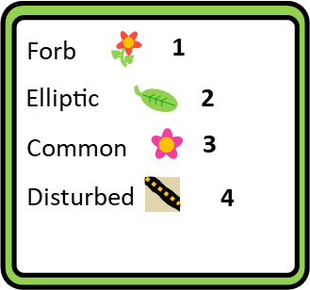
- This is the type of plant growth form, such as shrub or forb.
- This is the type of plant leaves on the plant.
- This is the type of flower or fruit of the plant.
- This is where the plant is located or its habitat.

Endophyte Traits:
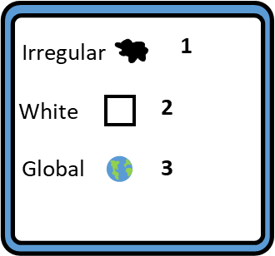
- This is the colony shape.
(Fungi will always be )
- This is the color of the microbe colony.
- This is where the endophyte can be found in the world.
It can be a habitat, a plant structure, or plant type.

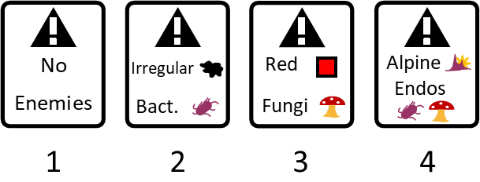
Enemy Interactions with other Endophytes:
- No enemies. Card will not attack other endophytes.
- Enemies of bacteria. Discard endophyte cards with traits listed.
- Enemies of fungi. Discard endophyte cards with traits listed.
- Enemies of either bacteria or fungi. Same as above.
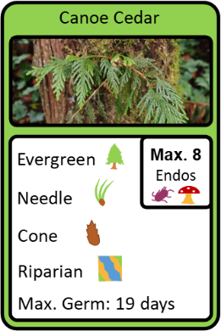
- When an endophyte card is drawn, you decide whether you want to keep it or give it to another player. It cannot be discarded during the round it is received.

Germination Days for Seed Species:
- Maximum germination days listed at bottom of Seed Card.
- Each round you earn days towards germination. Endophytes impact germination by reducing days or adding days.

Endophytes Attached to Seed Species:
- Maximum endophyte number inside small box. Example card, this seed can have a maximum of 8 endophytes attached to it.
- Keep endophytes for duration of game.

Pathogen Cards:
- Pathogen cards must be kept.
- Pathogen impacts to germination are tallied at the end of each round.

Counting Germination Impacts (bottom of endophyte card):
- Negative numbers reduce your days to germinate, helping you to win; whereas positive numbers add days to germination, taking longer to germinate. However, each seed cannot exceed its maximum germination days.
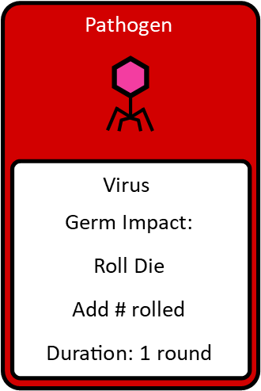
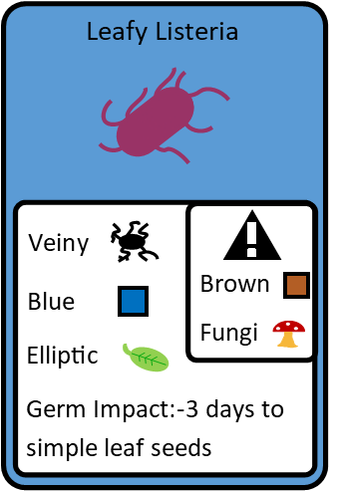

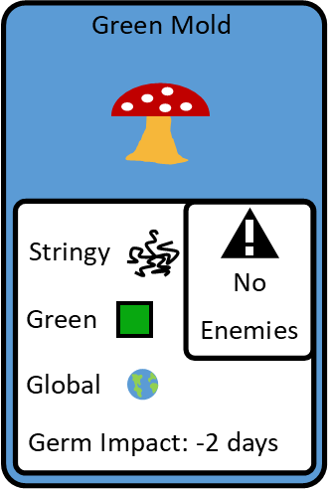

Rules:
- The goal is to germinate your seed first before the other players.
- When an endophyte card is drawn it must be kept or given to another player. It cannot be discarded on the round it is drawn.
- If you keep a card that contains an endophyte that attacks other endophytes, then the card(s) that have been attacked must be discarded. If there is ever an instance where two endophytes attack each other equally, then the newest card takes precedent.
- Each seed has a maximum number of endophytes that can be attached to the seed card. Players cannot hold on to extra cards but must give away any additional cards. Pathogens are not counted towards the maximum endophyte number.
- Endophytes remain with the seeds from one round to the next such that their impacts are counted with each round. When maximum endophyte number is reached, then cards can be discarded.
- Some endophyte cards, such as pathogen cards, contain additional instructions that are implemented at the end of the round.
- Seeds DO NOT progress towards germination without attached endophytes.

How to play:
- Setup: First, shuffle the endophyte cards together. These contain bacteria, fungi, pathogens, and some interacting climate scenario cards. Place deck within reach with an adjacent discard pile.
- Seed Selection: Each player will randomly draw a seed card from the seed deck. Place your seed card face up in front of you. Each game draw from new cards.
- Order Rotation: Roll the die. Player with the highest number goes first, then clockwise.
- Draw Endophyte Cards: Players can either keep the card they draw (attach it to their seed card) or force another player to attach the card to their seed. You must take a card given to you. Place your endophyte cards face up in front of you, so the other players can see.
- Pathogen: Pathogen cards cannot be given away. The card is kept for the number of rounds listed. The pathogens impact is indicated on the card. Pathogens do not count towards maximum endophyte number.
- Climate Change Cards: These cards alter some of the interactions—get ready!
- Record Keeping: For each round, record the number of negative numbers, reducing your days to germination, and positive numbers, adding days to germination if any. All endophytes that are attached to the seed (stacked) are counted at a given round.
- First person to achieve the number of days needed to germinate their seed is the winner! Or the person with the seed closest to germination after six rounds is the winner.
- In the event of a tie, the people who tied will each roll the die and the highest number wins (or you can get creative and decide your own tiebreaker).
- Play another game!
Photo Credits for Game Cards: Pictures for each card were photographed by people not involved with the creation of this card game. The photographers were not affiliated with the creation of this game. Each picture was cropped to fit the card size. Photos were public domain or with an Attribution 2.0 Generic License, allowing for copy, cropping, and redistribution of material with reference to the source website. All website links are provided below.

Western Yarrow: https://www.geograph.org.uk/photo/4663830
Prickly Phlox: https://commons.wikimedia.org/wiki/File:Phlox_diffusa_08740.JPG
Blue Flax Flower: https://www.flickr.com/photos/swallowtailgardenseeds/34432508282
Wild Mint: https://www.flickr.com/photos/plant_diversity/7938046454/
Glacier Lily: https://www.flickr.com/photos/fsnorthernregion/14511510064
Wildrye: https://www.flickr.com/photos/127605180@N04/16160624471
June Grass: https://www.flickr.com/photos/plant_diversity/29051865037
Squirreltail: https://www.flickr.com/photos/usfwsmtnprairie/27600543896
Idaho Fescue: https://www.flickr.com/photos/plant_diversity/48184780222
Arctic Bluegrass: https://fieldguide.mt.gov/speciesDetail.aspx?elcode=PMPOA4Z080
Bald-Hip Rose: https://www.flickr.com/photos/northcascadesnationalpark/7816372628
Western Peony: https://www.flickr.com/photos/127605180@N04/16850427152
Ocean Spray: https://picryl.com/media/bush-ocean-spray-or-rock-spirea-holodiscus-microphyllus-var-glabrescens-78588b
Golden Currant: https://pixabay.com/photos/currant-fruits-white-currants-550
Huckleberry: http://biology.burke.washington.edu/herbarium/imagecollection/photo.php?Photo=wtu060043&Taxon=Vaccinium%20membranaceum&SourcePage=taxon
Garry Oak: https://commons.wikimedia.org/wiki/File:Garry_Oak_Meadow_%2850060196206%29.jpg
River Birch: https://www.flickr.com/photos/tonyfrates/6496196269
Quaking Aspen: https://www.flickr.com/photos/zionnps/5205494244/in/photostream/
Fireberry Hawthorn: https://fieldguide.mt.gov/speciesDetail.aspx?elcode=PDROS0H840
Mountain Alder: https://commons.wikimedia.org/wiki/File:Alnus_alnobetula_subsp_alnobetula_2_RF.jpg
Bull Pine: https://www.flickr.com/photos/plant_diversity/50040811833
Western Juniper: https://pixahive.com/photo/western-juniper-on-hilltop/
Canoe Cedar: https://www.flickr.com/photos/jmaughn/16522080922
Western Yew: https://pixabay.com/photos/yew-berry-red-nature-evergreen-4581580/
Engelmann Spruce: https://commons.wikimedia.org/wiki/File:2013-07-14_11_02_29_Engelmann_Spruce_trees_near_tree_line_along_the_Wheeler_Peak_Summit_Trail.jpg

Game Acknowledgements for Glorious Germination
Game Designers: Dylan Eisenbrandt and Julie Beckstead
Game Development Assistance: Erik Hallstrand, Alexandrite Greenhouse, Mackenzie Rowley, Margarita Washington, and Abbey Shuster
Video Assistance: Abbey Shuster, Libby Shuster, and Sara Wifall
Photos for Game Materials but not Photos on Game Cards: Zack Berlat, Anna Muhich, and Julie Beckstead
Location of Research Program: Program is called Seeds For The Future. Students participated in the program at Gonzaga University (Spokane WA) and University of Idaho (Moscow ID). The development of this game occurred at Gonzaga University.
Funding: USDA NIFA Agriculture and Food Research Initiative - Research and Extension Experiences for Undergraduates (REEU; 2021-69018-34639 to George Mary Ridout, Julie Beckstead and George Newcombe) and the Gonzaga Science Research Program (2022-grant from Gonzaga University to JB).
Game Testers: Several classes of biology students and non-science major students taking a biology class contributed to the development of this game and their feedback is appreciated!

GLORIOUS GERMINATION – Do Microbes Help or Hinder Germination?
Score Sheet
For each round in a game, record the number of negative numbers, reducing your days to germination, and positive numbers, adding days to germination. Each endophyte’s impact gets counted for each round as they stay with the seed for the entire game.
GAME 1  Player’s name and seed type | # days to germinate | Round1 | Round2 | Round3 | Round4 | Round5 | Round6 | Winner | Key microbe interactions
Ex. Sally – Ponderosa Pine tree | 25 | 23 | 22 | 22 | 21 | 18 | 16 | No | Got a pathogen.
1
2
3
4
5

GAME 2  Player’s name and seed type | # days to germinate | Round1 | Round2 | Round3 | Round4 | Round5 | Round6 | Winner | Key microbe interactions
1
2
3
4
5

