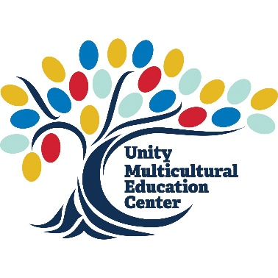
POSITION
Dialogue Facilitator (Intergroup Dialogue / Sustained Dialogue)
Unity Multicultural Education Center (UMEC)

TIME COMMITMENT
~5 hours per week during group run, additional training and meetings scheduled

PROGRAM OUTCOMES
Both dialogue programs are nationally recognized and researched programs with broad outcomes defined by the program creators:
- Develop intergroup understanding by helping students explore their own and others' social identities and statuses, and the role of social structures in relationships of privilege and inequality
- Foster positive intergroup relationships by developing students' empathy and motivation to bridge differences of identities and statuses
- Foster intergroup collaboration for personal and social responsibility toward greater social justice

In addition, we have set the following specific outcomes for GU faculty, staff, and student participants:
- Explore social identities, their intersections, and their relation to intergroup difference
- Engage with issues related to social justice and identity development
- Practice the skill of dialogue and differentiate between dialogue, debate, and discussion

SUPERVISION GIVEN/RECEIVED
Reports directly to the Program Manager for Intercultural Development of the Unity Multicultural Education Center (UMEC) and works closely with other faculty and staff

MINIMUM QUALIFICATIONS
- Supervisory approval
- An understanding of the goals of the program and the expectations of the position
- Staff, faculty, or graduate student status
- Ability to continue throughout the entirety of the semester
- Commitment to supporting the mission of the area of Diversity, Inclusion, Community, & Equity and UMEC and the ability to serve as an ambassador for the centers and their programs
- Ability to manage time in order to meet program and facilitator commitments
- Familiarity with concepts of power, privilege, and identity
- Comfort with identity-based conversation

MANDATORY REQUIREMENTS / EXPECTATIONS
- Attend (1) mandatory training workshop.
- Schedule and attend weekly 1-1 meetings with co-facilitator.
- Attend all weekly student group meetings unless previously discussed with co-facilitator and program manager.
- Maintain email contact with program manager, including reporting all issues and concerns in a timely manner.
- Maintain confidentiality regarding any personal or sensitive information shared with you in your role by students, other program staff, and program coordinators.

