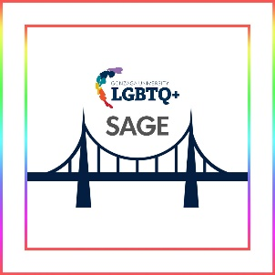
POSITION
Sexuality and Gender Equity (SAGE) Trainer
Lincoln LGBTQ+ Resource Center
TIME COMMITMENT
- Approximately 6 hours per month (including prep, presentation, assessment, and meetings)
- Mandatory day-long training to facilitate SAGE Levels I and III

PROGRAM OUTCOMES
- Increase LGBTQ+ cultural fluency at Gonzaga University.
- Cultivate an affirming campus environment for LGBTQ+ folks.
- Provide opportunities to ask questions regarding LGBTQ+ information.
- Construct a visible network of allies and community members across campus.

In addition, we have set the following specific outcomes for trainers:
- Explore topics of sexual orientation, gender identity, and gender expression.
- Engage with issues related to social justice and identity development.
- Practice the skill of facilitating LGBTQ+ trainings.

SUPERVISION GIVEN/RECEIVED
Reports directly to the Program Manager for LGBTQ+ Education & Support in the Lincoln LGBTQ+ Resource Center and works closely with other faculty and staff

MINIMUM QUALIFICATIONS
- Supervisory approval
- Must have completed both SAGE I & II before becoming trainers
- Understanding of the goals of the program and the expectations of the position
- Staff, faculty, or graduate student status
- Ability to continue throughout the entire academic year
- Commitment to supporting the mission of the Diversity, Inclusion, Community, & Equity (DICE) Department and Lincoln LGBTQ+ Resource Center, and the ability to serve as an ambassador for the centers and their programs
- Ability to manage time in order to meet program and trainer commitments
- Familiarity with concepts of power, privilege, and LGBTQ+ identities
- Comfort with identity-based conversation

EXPECTATIONS AND REQUIREMENTS
- Attend (1) full-day training workshop.
- Participate in (4) one-on-one meetings with the Program Manager to be scheduled based on mutual availability.
- Review resource materials and attend ongoing trainings as requested and available.
- Maintain email contact with Program Manager, including reporting all issues and concerns in a timely manner.
- Maintain privacy regarding any personal or sensitive information shared with you in your role by students, other program staff, and program coordinators.

